CHAPTER THREE
SYSTEM ANALYSIS AND DESIGN

3.1 Analysis of the Existing System
3.1.1 Architecture of the Existing System
The existing hostel management system in many Nigerian universities operates through manual, paper-based processes. Students must physically visit administrative offices, queue for long hours, and fill out paper forms for room allocation. Staff manually search through ledgers to check room availability, assign beds, and issue allocation slips. Attendance tracking relies on paper logbooks where students sign their names upon entry and exit. Complaint reporting is done verbally or through paper slips that are often misplaced. All records are stored in filing cabinets with no digital backup, making data retrieval slow and prone to errors.
The following diagram illustrates the architecture of the existing manual system:
text
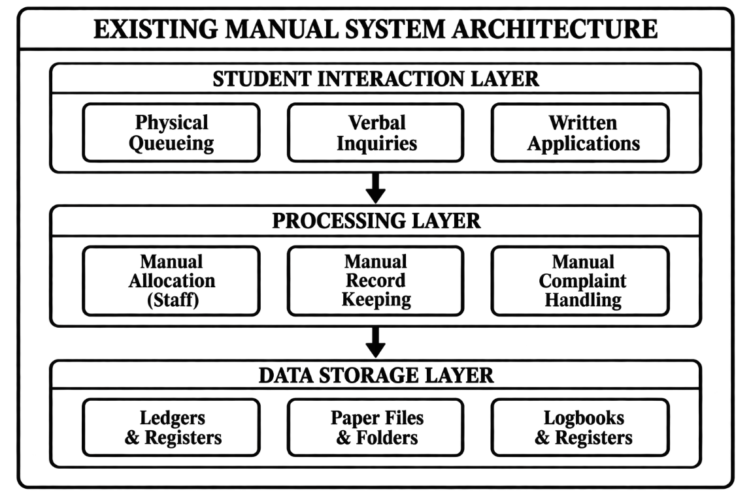
Figure 3.1: Architecture of Existing System

3.1.2 Constraints of the Existing System
The manual system suffers from numerous constraints:
Constraint Category | Specific Issues | Impact
Operational | Slow processing, data redundancy, no scalability | Students miss classes, staff overwhelmed
Security | Falsifiable logbooks, no audit trail, identity fraud | Security risks, disputes
Communication | No central platform, delayed updates, lost complaints | Student frustration, unresolved issues
Technical | No automation, error-prone processes, no remote access | Double allocation, inefficiency
Resource | High staff workload, paper costs, storage space | Wasted time and money

3.2 Analysis of the Proposed System
The proposed Student Hostel Management System is a web-based application designed to address these constraints through three integrated modules: rule-based room allocation, QR code attendance tracking, and complaint management.

3.2.1 Justification of the Proposed System
Justification Type | Benefits
Technical | Web-based platform, three-tier architecture, RESTful API, MongoDB for hierarchical data
Functional | Automated allocation, real-time occupancy, complaint tracking, OTP verification
Economic | Eliminates paper costs, reduces staff workload, prevents costly double allocation
Operational | 24/7 access, real-time updates, scalable, user-friendly interface

3.3 Method Adopted in the Study
3.3.1 Research Methodology
The Agile Software Development Methodology (Scrum framework) was adopted for this project. This methodology was chosen because:
- Iterative Development: The three core modules (allocation, attendance, complaints) could be developed and refined incrementally.
- User Involvement: Students and administrators were consulted throughout development.
- Flexibility: Requirements could be adjusted based on feedback.
- Early Delivery: Core functionalities were delivered early for testing.
- Risk Management: Issues were identified and resolved early in the cycle.
The following diagram illustrates the Agile development process:
text
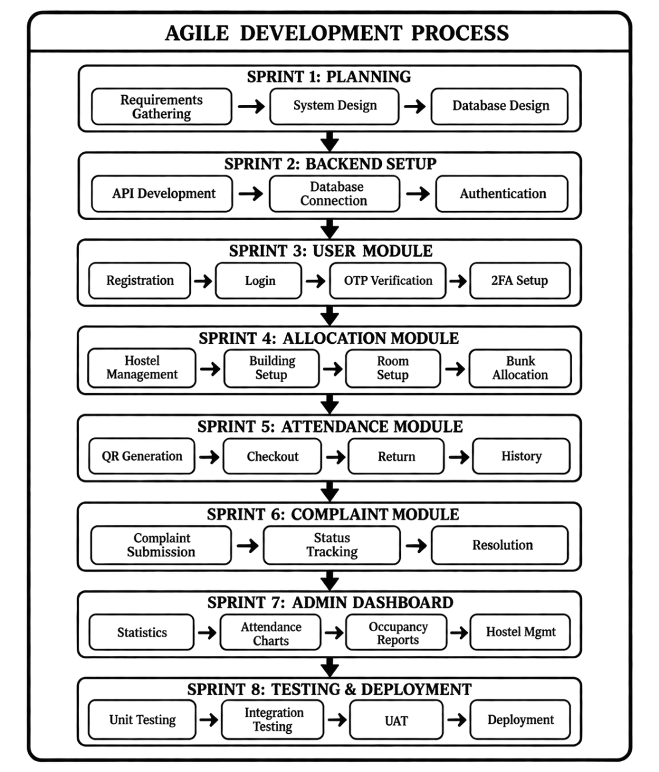
Figure 3.2: Agile Development Process

3.3.2 Research Approach
The research combined qualitative and quantitative methods:
Method | Details
Interviews | 3 hostel administrators, 5 porters, 15 students, 3 maintenance staff
Surveys | 50 students surveyed on waiting times, complaint resolution, satisfaction
Document Analysis | Allocation forms, logbooks, complaint registers, hostel policies

3.3.3 Development Tools
Category | Tools
Frontend | React.js, Redux Toolkit, Tailwind CSS, React Router, Lucide React
Backend | Node.js, Express.js, MongoDB, Mongoose, JWT, Bcrypt, Nodemailer
Deployment | Vercel (frontend), Railway (backend), MongoDB Atlas (database)

3.4 System Design
3.4.1 Architecture of the Proposed System
The system follows a three-tier client-server architecture:
1. Presentation Tier (Frontend - React.js) : Handles user interface and interactions. Provides separate interfaces for students, administrators, and porters.
2. Application Tier (Backend - Node.js/Express) : Contains business logic, authentication, and data processing. Includes controllers for users, hostel allocation, check-in/out, and complaints.
3. Data Tier (Database - MongoDB) : Stores all application data across eight collections: Users, Hostels, Buildings, Rooms, Bunks, CheckIns, Complaints, and Transactions.
The following diagram illustrates the complete system architecture:
text
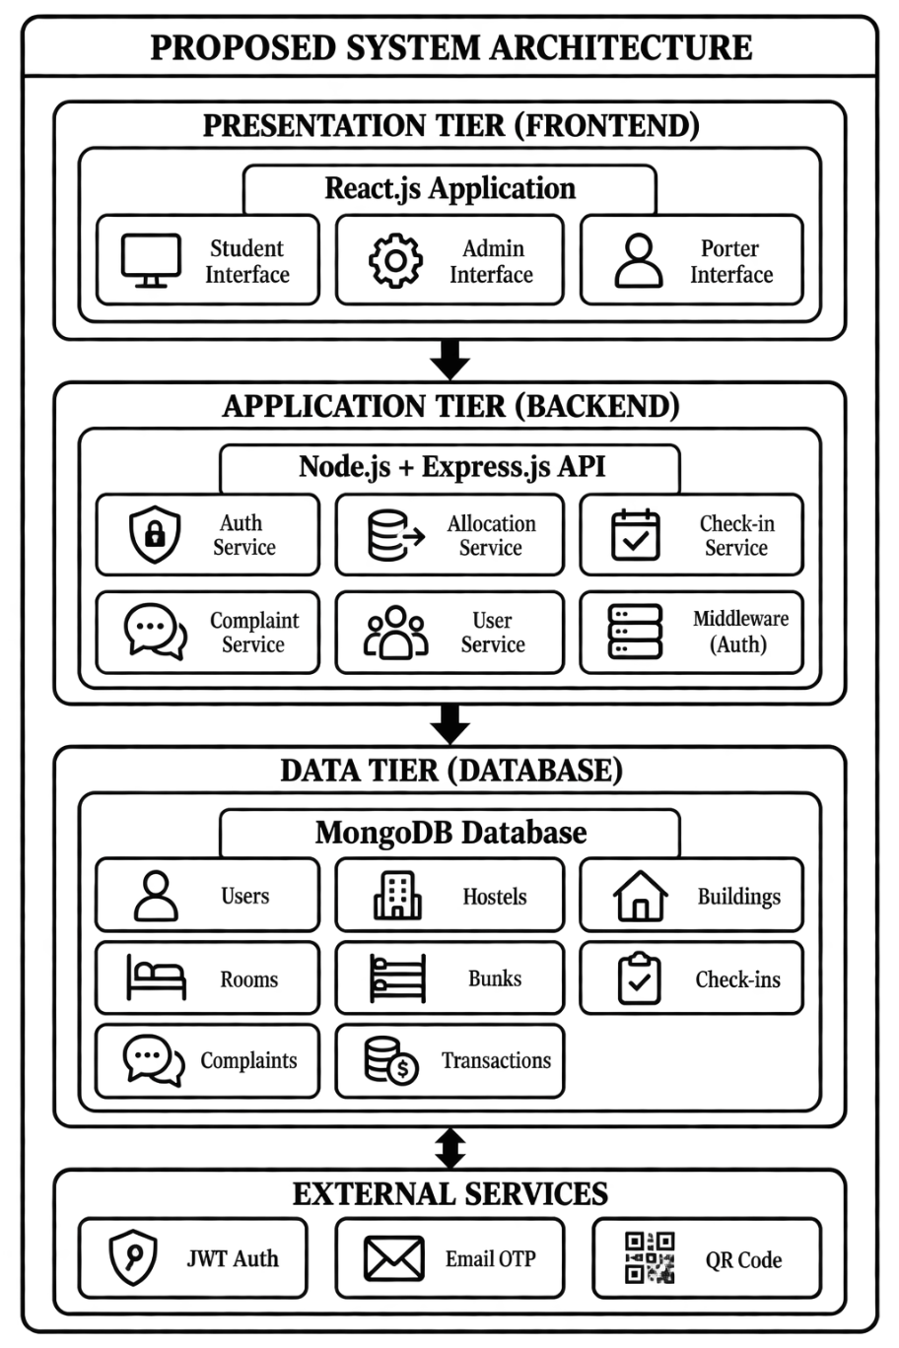
Figure 3.3: Proposed System Architecture

3.4.2 High Level Input Design
The system uses web forms with validation for data input:
Input Form | Key Fields | Validation
Student Registration | Full name, matric number, email, department, year of study, password | Required fields, unique email/matric, password min 6 chars
Hostel Creation | Hostel name, type (male/female), description | Required name, valid type
Building Creation | Select hostel, building name, description | Required hostel and building name
Room Creation | Select building, room number, bunk count, price | Required building, unique room number, bunk count ≥ 1
Complaint Submission | Title, description, category, anonymous flag | Required title and description
QR Scanner | Camera feed for QR code capture | Automatic JWT token validation

3.4.3 High Level Output Design
The system presents information to users through various interfaces:
Output | Key Information Displayed
Student Dashboard | Allocation status, QR code display, complaint count, recent activity
Admin Dashboard | Total students, checked in/out counts, weekly attendance chart, occupancy summary, recent activities, recent complaints
Complaint Tracking | Complaint details, current status, status timeline, action buttons
Hostel Management | Hierarchical view of hostels with buildings, rooms, and bunks; occupancy status

3.5 Database Design of the Proposed System
3.5.1 Entity-Relationship Diagram (ERD)
The database consists of eight collections with the following hierarchical structure:
- Hostel (1) → (M) Building
- Building (1) → (M) Room
- Room (1) → (M) Bunk
- Bunk (1) → (1) User (via allocatedBunk)
Additional relationships:
- User (1) → (M) CheckIn, Complaint, Transaction
- Bunk (1) → (M) CheckIn, Transaction
The following diagram illustrates the entity relationships:
text
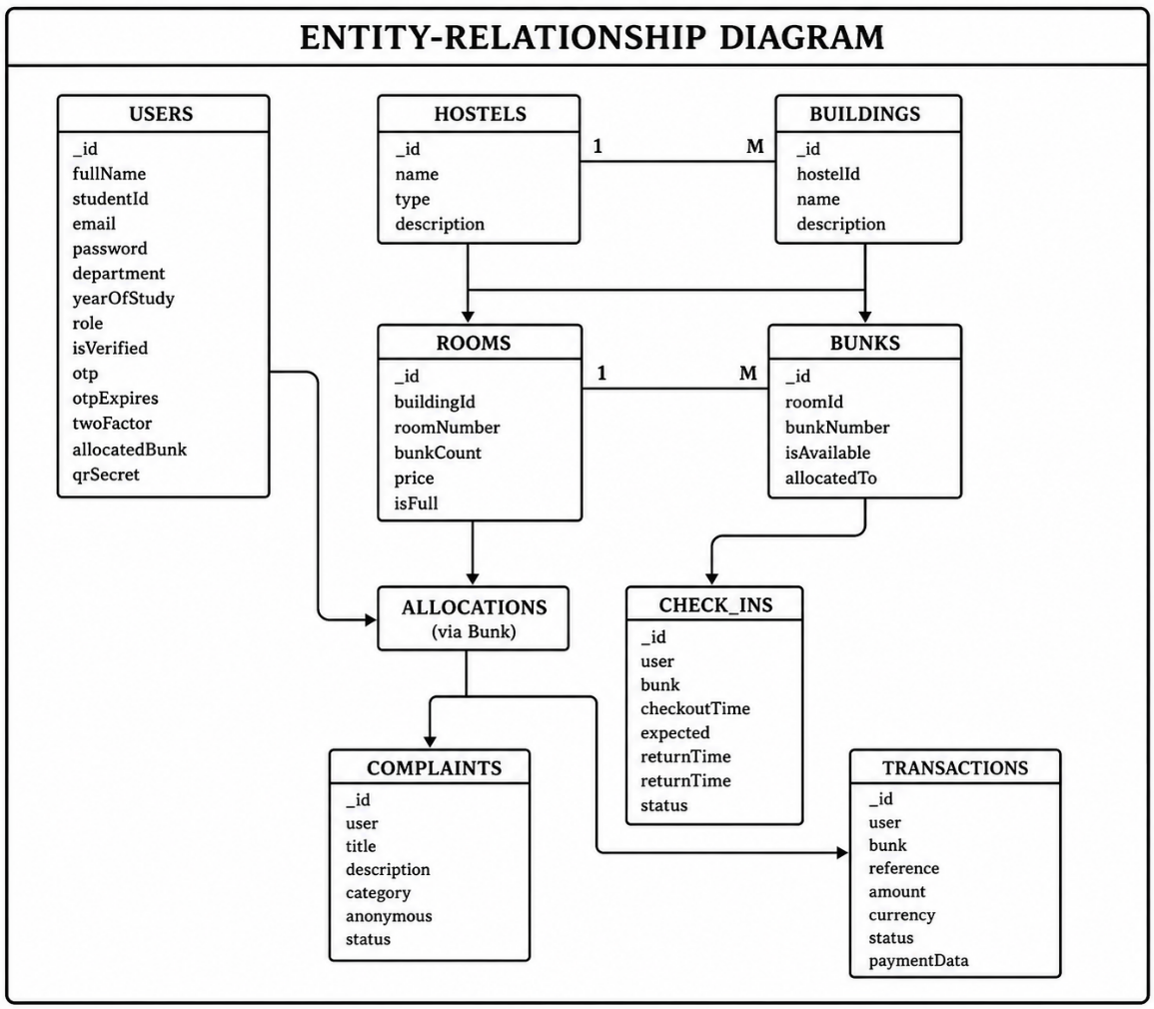
Figure 3.4: Entity-Relationship Diagram

3.5.2 Database Schema Description
1. Users Collection
Field | Type | Description | Constraints
_id | ObjectId | Unique identifier | Auto-generated
fullName | String | User's full name | Required
profilePicture | String | URL to profile image | Default: empty
studentId | String | Matriculation number | Required, Unique
institutionalEmail | String | School email | Required, Unique
department | String | Student's department | Required
yearOfStudy | Number | Current year (1-10) | Required
password | String | Hashed password | Required, min 6
role | String | user/admin/super_admin | Default: "user"
isVerified | Boolean | Email verification | Default: false
otp | String | One-time password | Default: null
otpExpires | Date | OTP expiration | Default: null
twoFactorEnabled | Boolean | 2FA status | Default: false
allocatedBunk | ObjectId | Reference to Bunk | Default: null
qrSecret | String | QR code secret | Default: null
createdAt | Date | Creation timestamp | Auto-generated
updatedAt | Date | Update timestamp | Auto-generated

2. Hostels Collection
Field | Type | Description | Constraints
_id | ObjectId | Unique identifier | Auto-generated
name | String | Hostel name | Required
type | String | male/female | Required
description | String | Additional details | Default: empty
createdAt | Date | Creation timestamp | Auto-generated
updatedAt | Date | Update timestamp | Auto-generated

3. Buildings Collection
Field | Type | Description | Constraints
_id | ObjectId | Unique identifier | Auto-generated
hostelId | ObjectId | Reference to Hostel | Required
name | String | Building name | Required
description | String | Additional details | Default: empty
createdAt | Date | Creation timestamp | Auto-generated
updatedAt | Date | Update timestamp | Auto-generated

4. Rooms Collection
Field | Type | Description | Constraints
_id | ObjectId | Unique identifier | Auto-generated
buildingId | ObjectId | Reference to Building | Required
roomNumber | String | Room identifier | Required
bunkCount | Number | Number of bunks | Required, min 1
price | Number | Room price | Default: 0
isFull | Boolean | Full status | Default: false
createdAt | Date | Creation timestamp | Auto-generated
updatedAt | Date | Update timestamp | Auto-generated

5. Bunks Collection
Field | Type | Description | Constraints
_id | ObjectId | Unique identifier | Auto-generated
roomId | ObjectId | Reference to Room | Required
bunkNumber | Number | Bunk identifier | Required, min 1
isAvailable | Boolean | Availability status | Default: true
allocatedTo | ObjectId | Reference to User | Default: null
createdAt | Date | Creation timestamp | Auto-generated
updatedAt | Date | Update timestamp | Auto-generated

6. CheckIns Collection
Field | Type | Description | Constraints
_id | ObjectId | Unique identifier | Auto-generated
user | ObjectId | Reference to User | Required
bunk | ObjectId | Reference to Bunk | Required
checkoutTime | Date | Time student left | Required
expectedReturnTime | Date | Expected return | Required
returnTime | Date | Actual return | Default: null
status | String | in/out | Default: "out"
createdAt | Date | Creation timestamp | Auto-generated
updatedAt | Date | Update timestamp | Auto-generated

7. Complaints Collection
Field | Type | Description | Constraints
_id | ObjectId | Unique identifier | Auto-generated
user | ObjectId | Reference to User | Required
title | String | Complaint title | Required
description | String | Complaint details | Required
category | String | Category | Default: "General"
anonymous | Boolean | Anonymous flag | Default: false
status | String | pending/read/done | Default: "pending"
createdAt | Date | Creation timestamp | Auto-generated
updatedAt | Date | Update timestamp | Auto-generated

8. Transactions Collection
Field | Type | Description | Constraints
_id | ObjectId | Unique identifier | Auto-generated
user | ObjectId | Reference to User | Required
bunk | ObjectId | Reference to Bunk | Required
reference | String | Transaction reference | Required, Unique
amount | Number | Payment amount | Required
currency | String | Currency code | Default: "NGN"
status | String | pending/paid/failed/refunded | Default: "pending"
paymentGateway | String | Gateway used | Default: "paystack"
paymentData | Mixed | Gateway response | Default: {}
createdAt | Date | Creation timestamp | Auto-generated
updatedAt | Date | Update timestamp | Auto-generated

3.5.3 Database Relationships Summary
Relationship | Type | Description
Hostel → Building | One-to-Many | A hostel has multiple buildings
Building → Room | One-to-Many | A building has multiple rooms
Room → Bunk | One-to-Many | A room has multiple bunks
Bunk → User | One-to-One | A bunk is allocated to one user
User → CheckIn | One-to-Many | A user has multiple check-in records
User → Complaint | One-to-Many | A user submits multiple complaints
User → Transaction | One-to-Many | A user has multiple transactions
Bunk → CheckIn | One-to-Many | A bunk has multiple check-in records
Bunk → Transaction | One-to-Many | A bunk has multiple transactions

3.5.4 Database Indexes
The following indexes ensure performance optimization:
Collection | Index | Purpose
Users | studentId (Unique) | Fast student lookup
Users | institutionalEmail (Unique) | Fast email lookup
Bunks | roomId + bunkNumber (Unique) | Prevent duplicate bunk numbers
Rooms | buildingId + roomNumber (Unique) | Prevent duplicate room numbers
Transactions | reference (Unique) | Fast transaction lookup
Transactions | user + createdAt | Fast user transaction history

3.6 Summary of Chapter Three
This chapter presented the analysis and design of the Student Hostel Management System based on the actual implementation reviewed from the project code.
The existing manual system was analysed and found to have significant constraints including slow processing, data redundancy, security vulnerabilities, lack of transparency, and high resource requirements. The proposed system addresses these through a three-tier architecture with web-based access, automated allocation, QR code attendance tracking, and complaint management.
The Agile development methodology was adopted with iterative development, user involvement, and early delivery of core functionalities. The system architecture comprises a React.js frontend, Node.js/Express backend, and MongoDB database with eight collections organized in a hierarchical structure.
Key design elements include registration and management forms with validation, dashboards displaying real-time statistics, and a comprehensive database schema with proper relationships and indexes.

